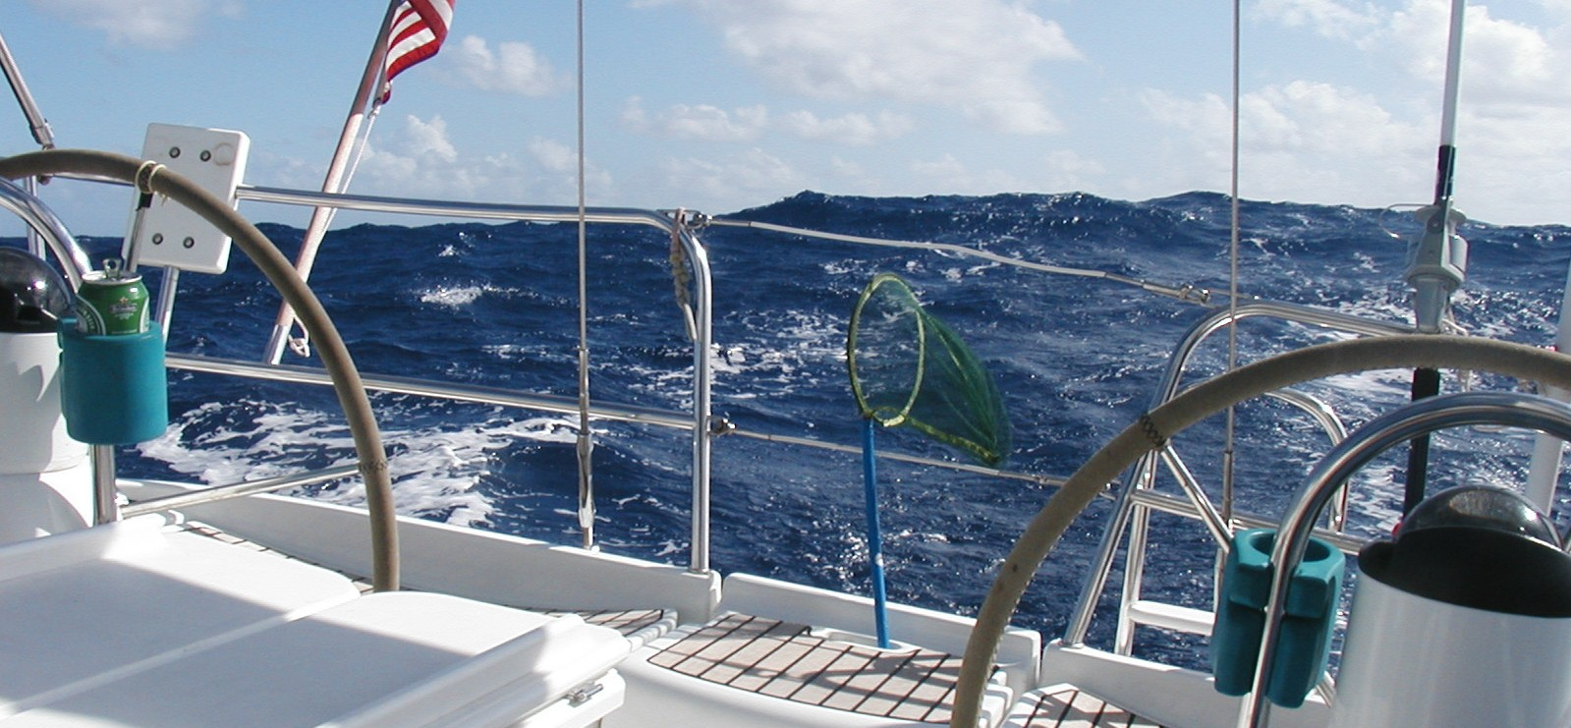
Estimating wave height with an on board Raspberry PI and SenseHat
Mauro Calvi
Skipper, S/V Bella Vita

It's a known fact that most mariners have a tendency to exaggerate the height of the waves as they recount their experiences with heavy weather at sea. In their defense, evaluating the height of waves at sea is a difficult task and an extremely subjective effort. The lack of reference objects of known height, other than the boat's mast (which one can only observe at a unfavorable angle) combined with the constantly changing height of the observation point (one's boat) relative to the incoming wave make the task almost impossible.
So it was only natural that when I came across the SenseHat I thought to myself: “well, if I can measure acceleration along three orthogonal axes, I should be able to calculate vertical velocity and space by applying the basic laws of kinematics, and finally have a fairly unbiased way of estimating the height of waves”.
Just a quick Google search later, I realized the problem of calculating the height of waves based on measured acceleration has been solved, as one would expect, multiple times, most notably by the NOAA, which uses buoys equipped with accelerometers to do just that. There is plenty of documentation available about the theory and math used to estimate wave height.
So I set out to connect a SenseHat I bought for the purpose to my on board Raspberry PI 2, and write a simple Python program that saves periodic wave height estimates to a CSV file. Following is a summary of what I learned and the results of a test I ran recently just sailing outside of the Golden Gate (where the ocean swell is fairly regular and predictable) on a fair weather day.
The significant wave height measurements reported by the RPI during the test appear to be fairly consistent with the values reported in the same period of time by NDBC Buoy 46026, located at the entrance of the San Francisco bay, not far from the test site.
Finally, caveat emptor! I am not a mathematician and my exposure to signal analysis goes back to my days as an engineering graduate student (a long time ago!), so take this all with a grain of sand. I would really welcome a review of the methodology by someone who is better qualified than I am. I also encourage you to submit pull requests to the code on github if you see ways to improve the program.

Methodology
The SenseHat provides acceleration readings (measured in Gs) along three orthogonal axis (x,y,z). I installed the SenseHat on top of the Raspberry PI 2, which is laid horizontally (i.e. as parallel as possible to the water surface) in the nav station compartment and with its longer side perpendicular to the boat's centerline. This way z can be used to track vertical acceleration relative to the boat frame, while x and y can be used to calculate pitch and roll respectively. With the boat at rest and the SenseHat mounted as described, both x and y measure close 0 g, while y measures close to 1 g. Of course, the actual values differ somewhat due to the installation not being 100% perpendicular to the direction of gravity, and the boat moving slightly even on a calm day at the marina. This requires some initial calibration.
I found the Sense Hat accelerometer is also rather noisy, particularly at high frequencies (significantly higher than those of typical waves, fortunately). This made the approach of integrating acceleration to obtain first velocity and then space close to impossible, as the noise was causing all sorts of runaway integral functions, as typical of highly noisy signals. So I ended up converting the accel time serieses into the frequency domain, which allowed me to easily filter out higher frequencies than the one I was interested in (NOAA uses the 0.03-0.4Hz range) and then calculating amplitude and dominant period.
At a high level, here's how the program works:
- the RPI reads acceleration values from the SenseHat every 200 msec. (It also reads a number of other variables such as temperature, humidity etc, which I translate to NMEA values and then send to a UDP port for use by other apps such as OpenCPM. But this is beyond the scope of this analysis)
- The vertical acceleration value relative to the earth frame (and converted to m/sec2) is obtained as the module of the vectorial sum of x, y and z (the boat is pitching and rolling all the time) and stored as a time series.
- Every 60 seconds a Fast Fourier Transform is applied to the the latter time series to coonvert the time series to the the frequency domain. Only values falling into typical wave and swell periods (4-20sec, or 0.05-0.25Hz) are considered
- When possible, a dominant frequency is identified by looking at the highest amplitude in the spectrum range.
- Amplitudes (acceleration) in the Frequency spectrum are converted into heights by means of double integration
- Calculate the Significant Wave Height (SWA). SWA is defined as the average of heights of the top 1/3 highest waves. Absent a series of wave height measurements, as in our case, it can be obtained from the frequency spectrum by multiplying the 0-order moment of the resulting wave height spectrum times 4..
- Values of SWA , period of dominant wave and Root Mean Square (RMS) of pitch and roll (in degrees) are saved to a csv file each minute (together with the the other aforementioned environmental values)
The program provides the option to save the charts of wave spectra as graphic files.

Code
The code is located at

Test
A simple test was performed on 1/28/2017 by recording wave height estimates outside of the San Francisco Golden gate for a couple of hours, and later comparing them to the values reported by a buoy in the general vicinity.
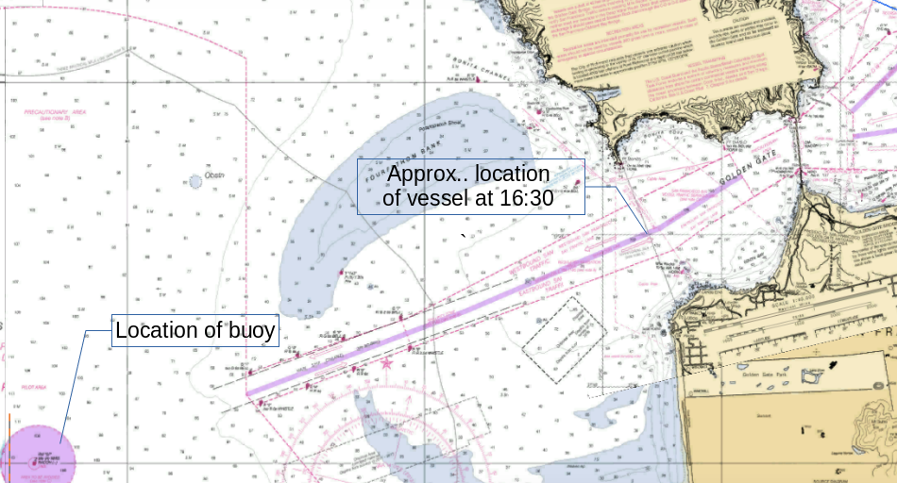

Plot of the estimated wave height during the test period (only values between 16 and 18 are relevant, as they at that time the boat was located outside of the Golden Gate)

NDBC Data for the test period

It would appear that the algorithm has a tendency to underestimate wave height by a significant factor (over 1:2). However, I think the difference between the estimated wave heights in the period 16:00 – 18:00 (when the boat was outside of the Golden Gate narrows, in the general area indicated on the chart) and the values reported by the NDBC buoy in the same perior of time could be explained by the boat being being approx 8 nm from the buoy and in an area southeast of the Fourthfathom bank, which tends to dampen the height of the prevailing northwest swell (my previous visual experience in offshore passages out of the Golden Gate confirms that).
In other words, the test is inconclusive, but it shows at least values that are somewhat consistent with what one would expect. I intend to repeat the test closer to NDBC Buoy in the near future.

References

National Data Buoy Center
http://www.ndbc.noaa.gov/wavecalc.shtml

http://journals.ametsoc.org/doi/pdf/10.1175/2010JTECHO724.1

The boat is a Benerteau 43, moored at the Sausalito Yacht Harbor, in the San Francisco Bay.
The vertical acceleration relative to earth frame so calculated is an approximation. A wave will cause a vessel to have non-vertical components of linear acceleration (for instance, when the boat is surfing down a steep wave, there will be a horizontal component to the acceleration). I am assuming that in most cruising conditions this approximation will be acceptable.

